Westminster International University in Tashkent
4ACCN008C-n Financial Accounting, Semester I, 2020/2021
Tutorial 9. Analysis of Financial Statements & Incomplete records

Task 1. Multiple Choice Questions

Q1. Which two of the following are valid reasons why the inventory turnover period of a company increases from one year to the next?

- A slowdown in trading
- A marketing decision to reduce selling prices
- Seasonal fluctuations in orders
- Obsolete goods

- 1 and 4
- 2 and 4
- 1 and 2
- 2 and 3

Q2 Which one of the following would help a company with high gearing to reduce its gearing ratio?

A. Issuing further long-term loan notes
B. Making a rights issue of equity shares
C. Paying dividends on its equity shares
D. Making a bonus issue of shares

Q3 A company's gross profit as a percentage of sales increased from 18% in the year ended 31 December 2018 to 22% in the year ended 31 December 2019.
Which of the following events is most likely to have caused the increase?

- An increase in sales volume
- A purchase in December 2018 mistakenly being recorded as happening in January 2019
- Overstatement of the closing inventory at 31 December 2018
- Understatement of the closing inventory at 31 December 2018

Q4 Which of the following is a ratio which is used to measure how much a business owes in relation to its size?
- Gearing
- Asset turnover
- Profit margin
- Return on capital employed

Q5 A business operates on a gross profit margin of 30%. Gross profit on a sale was $1,200, and expenses were $720. What is the net profit margin?

- 8.88%
- 12%
- 11.25%
- 19%

Q6 A business has compiled the following information for the year ended 31 March 2020:
$
Opening inventory 400,500
Purchases 1,050,000
Closing inventory 488,345

The gross profit as a percentage of sales is always 40%
Based on these figures, what is the sales revenue for the year?
- $1,488,320
- $1,603,592
- $2,000,500
- The sales revenue figure cannot be calculated from this information

Q7 A sole trader fixes his prices to achieve a gross profit percentage on sales revenue of 30%. All his sales are for cash. He suspects that one of his sales assistants is stealing cash from sales revenue.
His trading account for the month of July 2020 is as follows:
$
Recorded sales revenue 220,000
Cost of sales 195,000
Gross profit 25,000

Assuming that the cost of sales figure is correct, how much cash could the sales assistant have taken?
- $15,178
- $58,571
- $22,380
- It is not possible to calculate a figure from this information

Answers:
- A. A slowdown in trade increases the inventory turnover period. Assuming that inventory is still being ordered at the same rate, this can lead to a build up in inventory. Inventory levels also increase where there is no longer a demand for the product, for example due to obsolescence. Seasonal fluctuations in orders will affect the amount of inventory held at any one time, but they will not affect inventory turnover period year on year. A decision to reduce sales price would not directly affect either purchase price or level of inventory. If anything, it would be likely to reduce inventory holding period as the company moves to a low margin, fast turnover approach.

- B. Issuing further loan notes and paying dividends will increase gearing. A bonus issue simply capitalises reserves, so has no effect.

- D. Understatement of the December 2018 closing inventory will lead to understatement of December 2019 opening inventory and therefore understatement of cost of sales.

- A. The gearing ratio is used to assess how much the company owes in relation to its size.

- B. % $
Sales 100 4000
Cost of sales 70 2800
Gross profit 30 1200
Expenses 720
Net profit 12 480
- B $
Opening inventory 400,500
Purchases 1,050,000
Closing inventory (488,345)
Cost of sales 962,155

962,155 * 100/60 = 1,603,592
- B Cost of sales = $195,000
Therefore sales should be = $195,000 * 100/70 = $278,571
Theft = $278,571– 220 000 = $58,571

Task 2
Mickey Ltd and Donald Ltd, two separate companies manufacture IT equipment. Their financial statements at 31.12.2019 are the followings:

Profit and Loss Accounts for the year ended 31.12.2019

Mickey | Donald
 | $000 | $000
Sales | 2,150 | 1,512
Cost of sales | 1,430 | 1,148
Gross Profit | 720 | 364
Other Expenses | 250 | 190
Operating Profit | 470 | 174
Interest on Debentures | 20 | 60
Net profit before tax | 450 | 114
Taxation | 100 | 30
Net Profit after tax | 350 | 84
Dividends | 200 | 80
Retained Profit | 150 | 4

Balance Sheets as at 31.12.2019
Mickey Donald
$000 $000 $000 $000
Fixed Assets cost |  | 2,750 |  | 3,420
Depreciation |  | 980  1,770 |  | 2,524  896
Current Assets
Stock | 420 |  | 340
Debtors | 900 |  | 680
Cash | 40  1,360 |  | 1,020
Creditors due within one year
Creditors | 360 |  | 400
Dividends | 200 |  | 80
Overdraft | 200  760 |  | 560  1,040
Net current assets  Net assets |  | 600  2,370 |  | (20)  876
Debentures 10 % |  | 200  2,170 |  | 600  276
Capital and Reserves
Ordinary share capital |  | 1,200 |  | 200
Retained profits |  | 970  2,170 |  | 76  276

Required:
1. Calculate the following ratios:
a) ROCE
b) Current Ratio
c) Acid Ratio
d) Debtors Collection Period
e) Gross Profit Rate
f) Interest Coverage Ratio
g) Stock Turnover
h) Days Stock in Inventory
i) Asset Turnover
j) Total Debt to Total Asset
k) Gearing

2. Drawing upon your knowledge of accounting, comment upon the differences and similarities of the accounting ratios for Mickey and Donald. Which business seems to be the most efficient? Give possible reasons.

Answers:

1. Calculation of ratios:
a) 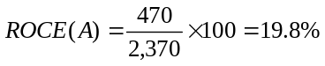
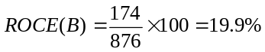

b) 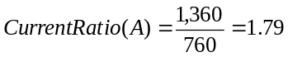times

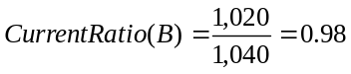times

c) 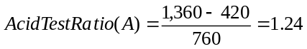times

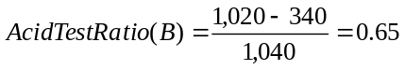times

d) 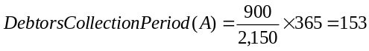 days

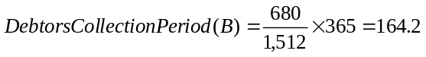days

e) 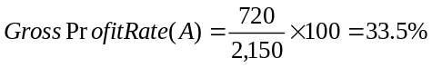

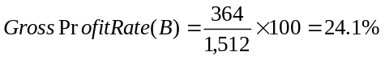

f) 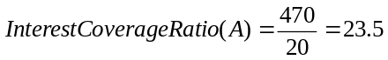times

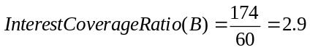times

g) 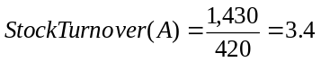times

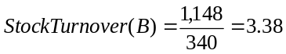 times

h) 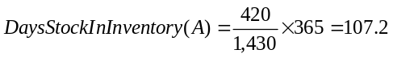 days

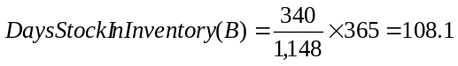days

i) 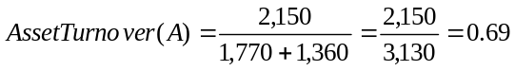times

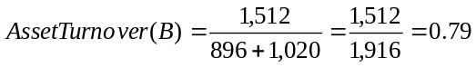times
The business is not generating a sufficient volume of business given its investment in total assets. To become more efficient, sales should be increased. Or some assets should be disposed

j) 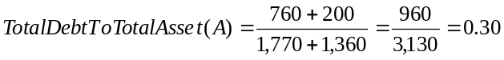times

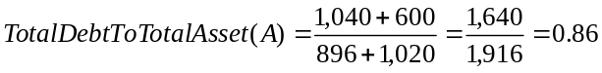times

k) 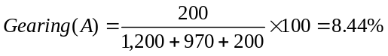

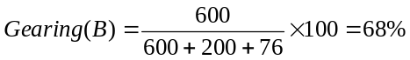

2.
a) ROCE is very similar for both companies.
b) Mickey’s liquidity is much better than Donald’s. This might be because of large bank overdraft of Donald.
c) Acid test ratio of Mickey is higher than Donald’s. Donald’s acid test ratio is below 1 (only 0.65), which means that this company may have liquidity problems.
d) Debt collection period for Mickey is shorter than for Donald.
e) Gross profit rate for Mickey is 33.5$ out of 100$, while its only 24.1$ for Donald.
f) Interest coverage ratio for Mickey is much higher than for Donald. This means that company MIckey has the better safety margin in meeting its interest payment commitments than Donald.
g) Stock turnover is very similar for both companies.
h) Days stock in inventory is also almost the same for both companies.
i) Asset turnover for Donald is better than for Mickey.
j) Donald’s assets are financed more by loans than those of Mickey’s.
k) Donald is high geared and thus potentially at risk if profit will decrease. Donald has high risk and it might be risky for ordinary shareholders. Mickey is low geared and appears to be stable.

Task 3 (Hometask) From Financial statements of Ocean LTD, a retailer, identify:

1. Five points of interest from comparing this year’s results with those of the previous years
2. Calculate the following ratios for Ocean Ltd to enable you to assess the performance of the company in the current year. Identify any further information you might find useful.
a) ROCE
b) Gross Profit margin
c) Stock Turnover
d) Debtors Turnover
e) Days Stock in Inventory
f) Current Ratio
g) Acid Ratio
h) Gearing Ratio
i) Interest Cover

Profit and Loss Accounts for the years ended

31.12.2018 31.12.2019
 | $000 | $000
Sales | 1,168 | 1,944
Cost of sales | 778 | 1370
Gross Profit | 390 | 574
Wages and salaries | 156 | 202
Depreciation | 32 | 62
Other Expenses | 108 | 124
Operating Profit | 94 | 186
Interest on Debentures |  | 16
Net profit before tax | 94 | 170
Taxation | 32 | 78
Net Profit after tax | 62 | 92
Dividends | 32 | 46
Retained Profit | 30 | 46

Balance Sheets as at

$000 $000
 | 31.12.2018 |  | 31.12.2019
Fixed Assets cost |  | 560 |  | 856
Current Assets
Stock | 94 |  | 124
Debtors | 140 |  | 312
Cash | 78  312 |  | 32  468
Creditors due within one year
Creditors | 78 |  | 218
Dividends | 32 |  | 46
Taxation | 32  142 |  | 78  342
Net current assets |  | 170 |  | 126
Creditors greater than 1 year  Debentures 10 % |  | 0  730 |  | 160  822
Capital and Reserves
Ordinary Share Capital |  | 544 |  | 590
Retained Profits |  | 186 |  | 232
 |  | 730 |  | 822

Answers:
1. Here is the list of possible changes in year 2019 compared those with the results of year 2018

a) Sales have increased by 66 % from 2018 levels.
b) Cost of the sales has increased by 76 % on 2018 levels.
c) All expenses have increased
d) Profit after tax increased by 50 %
e) Fixed assets increased substantially
f) Net current assets reduced but stock, debtors, creditors all increased in value
g) Debentures and shares issued 2019, more capital raised

2. a) 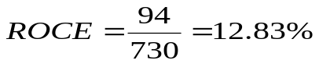(2018)
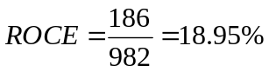 (2019)
This indicates an increase in profitability of the business from the increased investment

b) 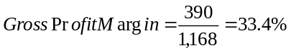 (2018)
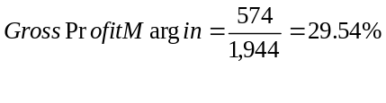 (2019)
This reduction in the ratio is probably due to a decrease in sales prices which has generated more sales or an increase in cost of goods sold.

c) 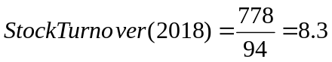times
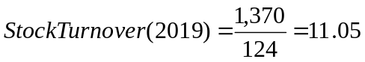times

d) 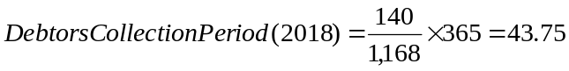days

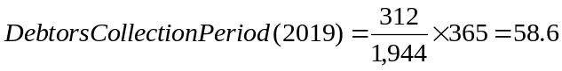 days

e) 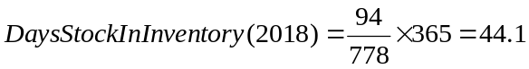 days

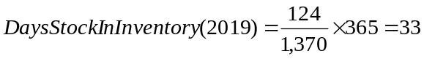 days

f) 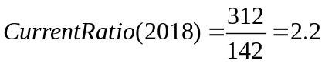times
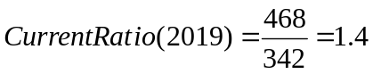times

g) 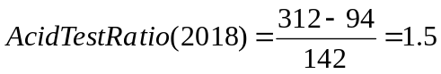 times

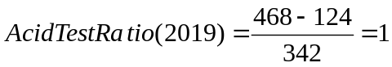 times

h) 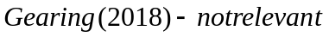
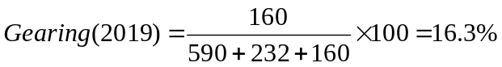

i)

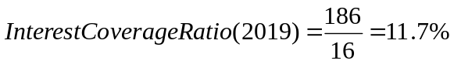

Task 4 Incomplete Records

Rozalia Rose's business has the following assets and liabilities as at 1 January 2019.
$
Fixtures and fittings at cost 7,000
Accumulated depreciation, fixtures and fittings 4,000
Motor vehicles at cost 12,000
Accumulated depreciation, motor vehicles 6,800
Inventory 4,500
Trade receivables 5,200
Cash at bank and in hand 1,230
Trade payables 3,700
Prepayment 450
Accrued rent 2,000

Required
Prepare a statement of financial position for the business, inserting a balancing figure for proprietor's
capital.

Answer
STATEMENT OF FINANCIAL POSITION AS AT 1 JANUARY 2019
$ $
Assets
Non-current assets
Fixtures and fittings at cost 7,000
Less accumulated depreciation 4,000
3,000
Motor vehicles at cost 12,000
Less accumulated depreciation 6,800
5,200
Current assets
Inventory 4,500
Trade receivables 5,200
Prepayment 450
Cash 1,230
11,380
Total assets 19,580
Capital and liabilities
Proprietor's capital as at 1 January 20X9 (balancing figure)* 13,880
Current liabilities
Trade payables 3,700
Accrual 2,000
5,700
Total capital and liabilities 19,580

* Calculated as follows:
Assets = Capital + Liabilities
19,580 = Capital + 5,700
Capital = 19,580 – 5,700
Capital = $13,880

Task 5

- A business has net assets of $60,000 at the beginning of the year and $70,000 at the end of the year. Drawings were $15,000 and a lottery win of $10,000 was paid into the business during the year. What was the profit for the year?

- A business has opening payables of $88,000 and closing payables of $78,000. Cash paid to suppliers was $78,000 and discounts received were $4,000. What is the figure for purchases?

- A business usually has a mark-up of 25% on cost of sales. During a year, its sales were $162,000. What was cost of sales?

Answers

- Profit = movement in net assets – capital introduced + drawings = (70,000 – 60,000) – 10,000 + 15,000= 15,000 profit

- PAYABLES CONTROL

$ $
Bank 78,000 Opening Payables 88,000
Discounts received 4,000 Purchases (bal.figure) 72,000
Closing Payables 78,000
160,000 160,000

- $
Sales 162,000
Cost of sales (bal. fig.) 129,600
Profit (25/125 *162 000) 32,400

